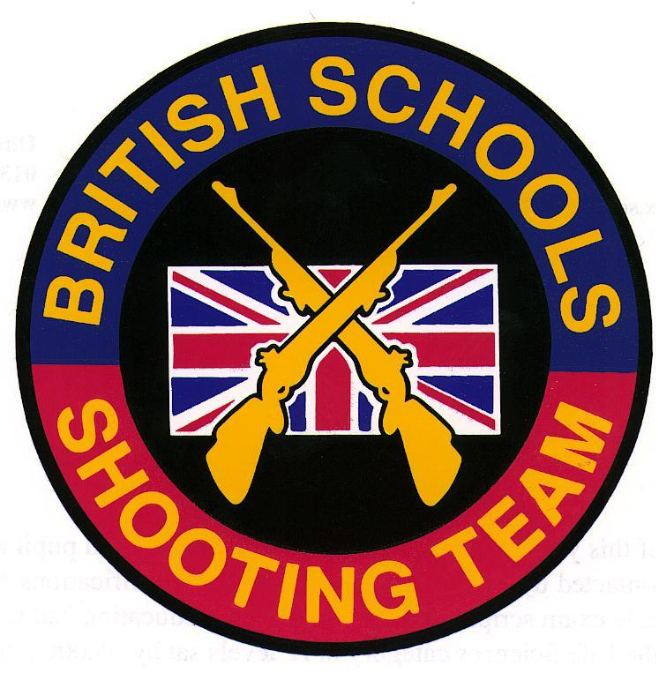
DANISH NATIONAL CHAMPIONSHIPS
Esbjerg, Denmark
(3-7 July 2013)

SPONSORS: ELEY Ltd

Report by Charles Lee (Team Manager)

Every four years in Denmark, a massive Festival of Sports and Culture is organised in an event known as ‘Landsstaevne’. This year the event was hosted by the town of Esbjerg and attracted in excess of 30,000 participants.

This is the sixth time that the British Schools Shooting Team has been invited to participate at this prestigious event. The team was selected from those Juniors who had represented the BSSRA in the 2013 postal match against New Zealand:

Richard Lay (Ellesmere College)
James Slater (Ellesmere College)
Katy Leeming (Ellesmere College)
Tom Brabrook (Felsted School)
Theo Dodds (Tonbridge School)
Sara Carr (Seaford College)

The six young rifle shooters (and their coaches), bedecked in union flags, made their presence well and truly known at the opening ceremony: covered live on national television, our colourful team was easily picked out by the cameras!
The serious side of the event for our team involved individual rifle competitions and the all-important international team match against the Danish Junior team. Commentary on the team match was provided throughout over a loud-speaker system and individual scores were announced after each 10 shots. Although somewhat nerve-wracking for the shooters, this was excellent for the large crowd who were watching and created a really exciting atmosphere, especially as the scores were so close.

Team match results
1. Denmark

Signe Steffensen 299
Frederikkke Frederiksen 297
Tobias Hybholt 297
Mette Nielsen 296
Sofie Nielsen 294
Stine Jensen 293

Total 1776

2. British Schools Team

Sara Carr 298
Theo Dodds 298
James Slater 297
Richard Lay 295
Thomas Brabrook 295
Katy Leeming 287

Total 1770

There were some excellent performances in the individual shooting events. Sara Carr shot extremely well in the 50m time limit shoot, scoring a maximum 300 and finishing in silver medal position overall (ex 138 competitors). Theo Dodds went one better in the field target shooting competition, a particularly challenging event that was shot over a wide range of different distances and in very blustery conditions: Theo finished with the remarkable score of 78 (ex 80), winning the individual gold medal in the process.

As with previous British Schools tours, we had plenty of time to enjoy other activities whilst in Denmark. The many exciting Landsstaevne events included the spectacular Opening and Closing Ceremonies in the packed main stadium.

I would like to thank everyone who made this such a successful tour, particularly Tom Rylands for all his assistance. The BSSRA is also indebted to the many DDS officials who worked so tirelessly on our behalf, especially Torben Klit Anderson. In addition, a major vote of thanks is due to all at Eley Ltd. for their continuing financial support of British Schools team activities. As usual, the high scores that we achieved were once again due in no small part to the excellent Tenex EPS ammunition that was made available for our use.
The team behaved impeccably throughout the trip, and did an enormous amount of good to enhance the reputation of the British Schools Small-Bore Rifle Association. There is no doubt at all that we are very much looking forward to our next visit to Denmark, which we hope will be in the summer of 2015!

For information about future BSSRA tours, please contact Dr.C.R.S.Lee, Felsted School, Felsted, Essex CM6 3LL (e-mail: crsl@felsted.org)

