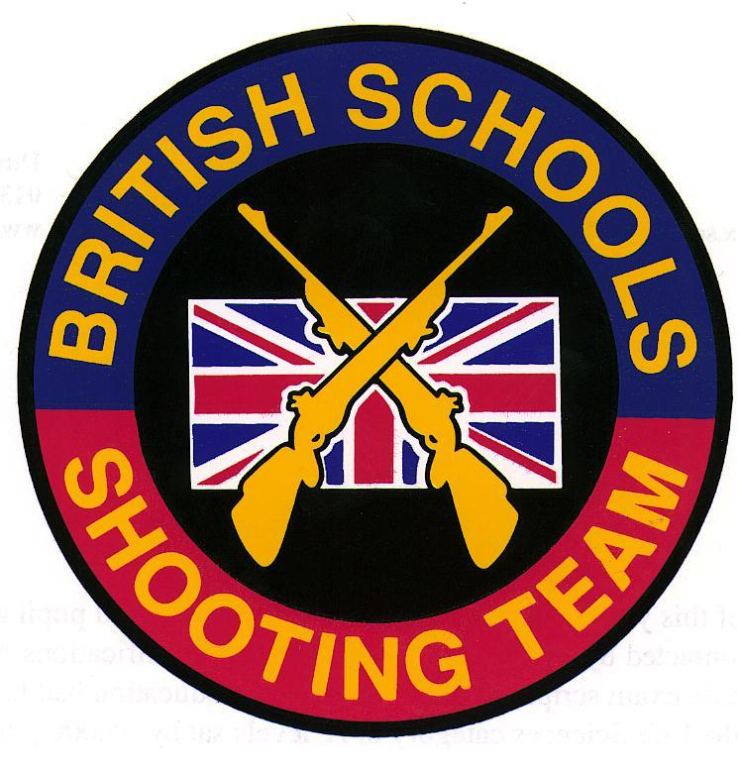
DANISH DDS NATIONAL CHAMPIONSHIPS
Vingsted, Denmark
(July 2011)
SPONSORS: ELEY Ltd
Report by Charles Lee (Team Manager)

This is the tenth time that the British Schools Shooting Team has been invited to participate at the Danish National Championships, which take place every two years. The team was selected from those Juniors who had performed well in the 2011 postal match against New Zealand:

Benjamin Bryant (Abingdon School)
Richard Belcher (Ellesmere College)
Henry Howard (Gresham’s School)
Tom Brabrook (Felsted School)
Chloe Evans (Gresham’s School)
Finn Riley (Abingdon School)
The Championships involved individual rifle competitions, as well as the all-important international team match against Denmark and, this year, Sweden. The scores for the team match were updated shot by shot on large electronic displays which could even be followed back in the UK via a live internet feed. This was excellent for the large crowd who were watching and created a really exciting atmosphere, especially as the final scores were so close:

Team Match result

1.Sweden

Linn Larsson 298 (9 V-bulls)
Emma Persson 297
Erik Lundqvist 297
Peter Joelsson 297
Carl Storck 296
Andreas Christensson 292

Total 1777

2. British Schools Team

Richard Belcher 298 (15 V-bulls) (Individual silver medal)
Ben Bryant 297
Chloe Evans 297
Henry Howard 296
Finn Riley 294
Tom Brabrook 290

Total 1772

3. Denmark Juniors

Camilla Birch Nielsen 298 (19 V-bulls)
Jens Holmgaard Nissen 297
Louise Chrsitiansen 295
Christer Marnaes 295
Mette Kjaergaard Pedersen 292
Mads Hansen 292

Total 1769

The following day we were delighted to see Finn Riley picking up a silver medal in the overall individual championship, scoring 147 (ex 150) and 150 (ex 150) in extremely testing conditions.

As with previous British Schools tours, we had plenty of time to enjoy other activities whilst in Denmark, and the team found time to visit many of the local Danish sites and attractions, including Legoland.

I would like to thank everyone who made this such a successful tour, particularly Alastair McDonald and Michelle Smith for all their assistance. Alastair made another enormous contribution to the tour and we are very grateful for all his efforts. Michelle had previously represented the British Schools team on a number of occasions as a Junior, but this was the first time that she had travelled as an adult coach and the team benefited greatly from her knowledge and experience. Like Alastair, she made a massive contribution to the overall success of the tour.

The BSSRA is also indebted to the many DDS officials who worked so tirelessly on our behalf, especially Torben Klit Anderson, Leif Bey and Christian Kjaer. In addition, a major vote of thanks is due to all at Eley Ltd. for their continuing financial support of British Schools team activities. As usual, the high scores that we achieved were once again due in no small part to the excellent Tenex ammunition that was made available for our use.
The team behaved impeccably throughout the trip, and did an enormous amount of good to enhance the reputation of the British Schools Small-Bore Rifle Association. There is no doubt at all that we are very much looking forward to our next visit to Denmark in the summer of 2013!

For information about future BSSRA tours, please contact Dr. C.R.S.Lee, Felsted School, Felsted, Essex CM6 3LL (e-mail: crsl@felsted.org)

