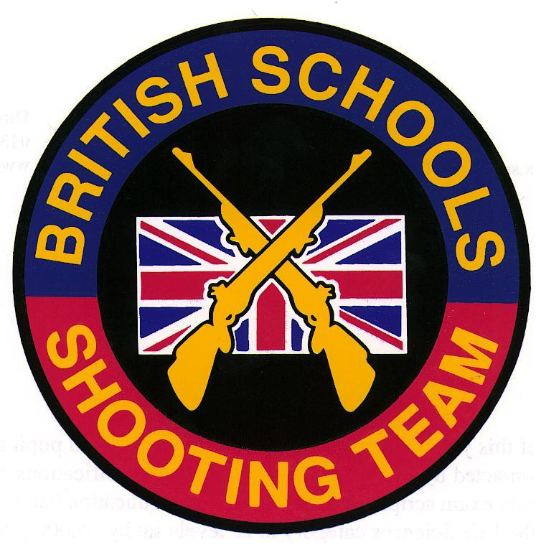
DANISH DDS NATIONAL CHAMPIONSHIPS
Holbaek, Denmark
(July 2009)

SPONSORS: ELEY Ltd

Report by Charles Lee (Team Manager)

Every four years, the Danish Shooting Association (DDS) and the Danish Gymnastics Association (DGI) come together to celebrate the Danish Festival of Sports and Culture in an event known as Landsstaevne. This year the event was in Hoelbek near Copenhagen and attracted in excess of 20,000 participants.

This is the fifth time that the British Schools Shooting Team has been invited to participate at this prestigious event. The team was selected from those Juniors who had represented the BSSRA in the 2009 postal match against New Zealand:

Craig Attwood (Gillingham School)
Harriet Bennett (Greshams School)
Michael Snell (Exeter School)
Robert Stilgoe (Gresham’s School)
Ruth Duffield (Sedbergh School)
Roland Johnson (Gresham’s School)

The six young rifle shooters (and their coaches), bedecked in union flags, made their presence well and truly known at the opening ceremony: covered live on national television, our colourful team was easily picked out by the cameras!
The serious side of the event for our team involved individual rifle competitions and the all-important international team match against Denmark. Commentary on the team match was provided throughout over a loud-speaker system and individual scores were announced after each 10 shots. Although a little distracting (and indeed somewhat nerve-wracking) for the shooters, this was excellent for the large crowd who were watching and created a really exciting atmosphere, especially as the scores were so close. At the end of the match the scores were tied, and the result had to be decided on V-bulls, which Denmark won, scoring 86 v-bulls to the British Schools team’s 68.

Team match results
1. Denmark

Jonas Hansen 300
Stine Mortensen, TingstedStine Mortensen 298
Andreas Brunsgaard Laursen, ViborgKristian Lynggard 298
Andreas Layrsen 295
Benn Stege, Skanderborg‐StillingBenn Stege 295
Daniel Jensen, KorsørDaniel Jensen 284Jonas Hansen, Stenløse

Total 1770

2. British Schools Team

Craig Attwood 300
Harriett Bennett 298
Robert Stilgoe 297
Michael Snell 295
Ruth Duffield 291
Roland Johnson 289

Total 1770

Having finished second in the concurrent individual competition on v-bulls, Craig Attwood also scored maximum points the following day in both the qualifying round and the final of the 50m Junior competition, winning the individual gold medal in the process. Harriett Bennett finished second in the 200m full-bore event, winning silver.

As with previous British Schools tours, we had plenty of time to enjoy other activities whilst in Denmark. Along with the many spectacular and exciting Landsstaevne events, our team also found time to visit many of the local Danish sites and attractions, including Copenhagen’s Tivoli Gardens.

I would like to thank everyone who made this such a successful tour, particularly Barry Mcadam and Alastair McDonald for all their assistance. Alastair, in particular, made an enormous contribution to the tour and we are very grateful for all his efforts. The BSSRA is also indebted to the many DDS officials who worked so tirelessly on our behalf, especially Kresten Hansen, Torben Klit Anderson, Leif Bey and Christian Kjaer.
In addition, a major vote of thanks is due to all at Eley Ltd. for their continuing financial support of British Schools team activities. As usual, the high scores that we achieved were once again due in no small part to the excellent Tenex EPS ammunition that was made available for our use.
The team behaved impeccably throughout the trip, and did an enormous amount of good to enhance the reputation of the British Schools Small-Bore Rifle Association. There is no doubt at all that we are very much looking forward to our next visit to Denmark in the summer of 2011!

For information about future BSSRA tours, please contact C.R.S.Lee Esq., Felsted School, Felsted, Essex CM6 3LL (e-mail: crsl@felsted.org)

